HOME PAGE:

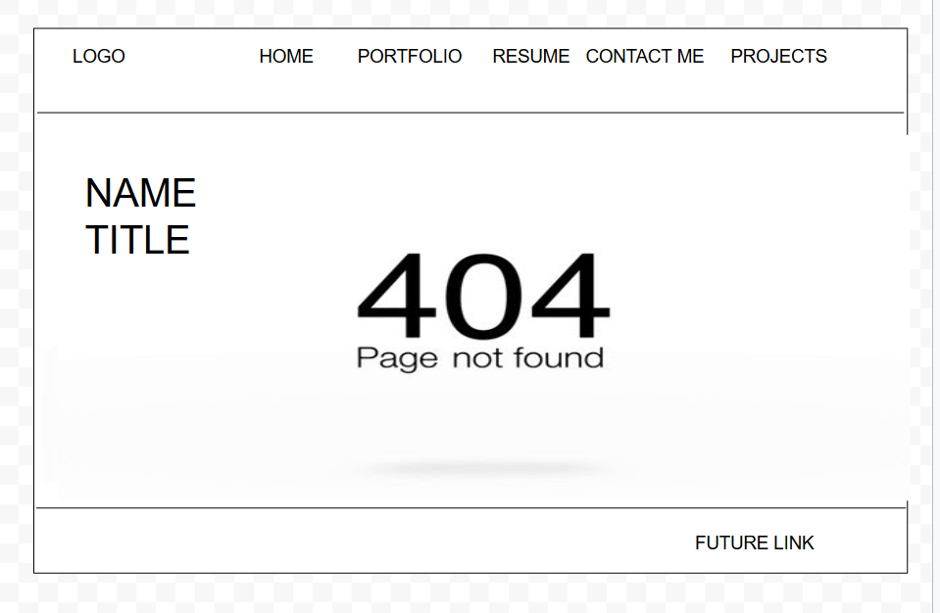

PORTFOLIO:

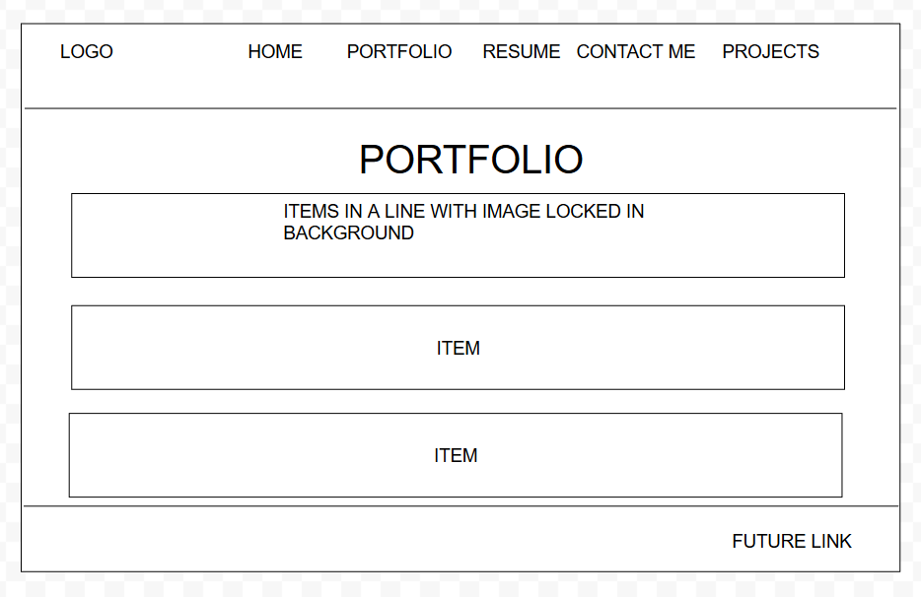

CONTACT ME:

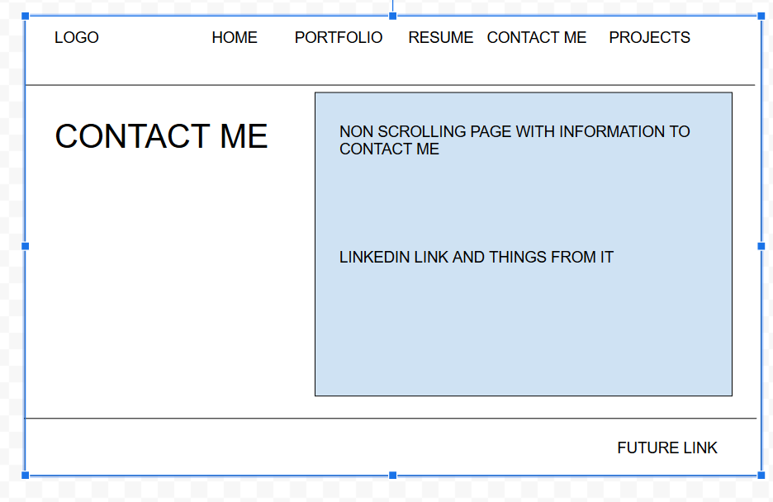

PROJECTS:

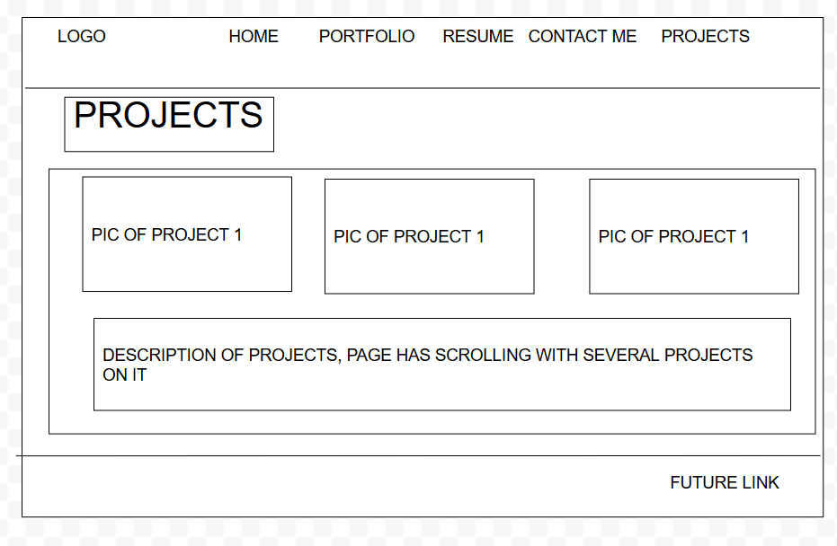

<img src="https://docs.google.com/drawings/d/e/2PACX-1vSm9tGzqhZmyqXWaZ9BMNo1Jr2QBwhD2N4TLrccDWcMAt4IJ2lPyTPoXDJvbuvEq3PxP8wd64fbsi9m/pub?w=960&amp;h=720">